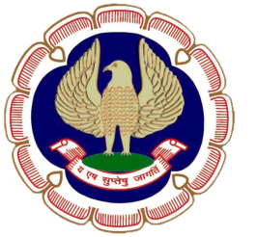
SICASA
ERNAKULAM BRANCH OF SOUTHERN INDIA
CHARTERED ACCOUNTANTS STUDENTS’ ASSOCIATION OF
THE INSTITUTE OF CHARTERED ACCOUNTANTS OF INDIA

“ICAI Bhawan”, Diwan’s Road, Kochi – 682016. Ph : 0484 – 2372953
Email : ernakulam@icai.org Website : www. sicasaernakulam.in

cordially invite you to the

ONE DAY SEMINAR

ON

COMPANY AUDIT

on Friday, 26th May, 2017

at ICAI Bhawan, Ernakulam

Time : 9.30 am to 4.00 pm

CA. ROY VARGHESE  Chairman, SICASA, EKM | CA. RENJTIH R. WARRIER Member, SICASA, EKM | MR. FARZEEN FAZAL Secretary, SICASA, EKM

---------------------------------------------------------------------------------------------------------------------
Registration Fee : 100/- ---------------------------------------------------------------------------------------------------------------------
MEMBERS ARE ALSO WELCOME

Programme Overleaf.

ONE DAY SEMINAR ON COMPANY AUDIT
26.05.2017

PROGRAMME

09.30 am. - Registration

10.00 am. - Inauguration

10.30 am. - 1st Technical Session

AUDIT OF COMPANIES UNDER COMPANIES ACT, 2013 –
A Practical Approach

Speaker : CA. SHYAM MAHADEVAN

01.00 p.m. - Lunch

01.45 pm. - 2nd Technical Session

COMPLIANCE UNDER COMPANIES ACT, 2013

Speaker: CA. SHERRY SAMUEL OOMMEN

04.00pm - Vote of Thanks

04.15pm - Tea & Snacks

***********

