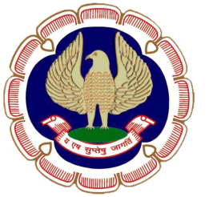
SICASA
ERNAKULAM BRANCH OF SOUTHERN INDIA
CHARTERED ACCOUNTANTS STUDENTS’ ASSOCIATION OF
THE INSTITUTE OF CHARTERED ACCOUNTANTS OF INDIA

“ICAI Bhawan”, Diwan’s Road, Kochi – 682016. Ph : 0484 – 2372953
Email : ernakulam@icai.org Website : www. sicasaernakulam.in

cordially invite you to the

HALF DAY SEMINAR

ON

TDS & TCS PROVISIONS &

REVISED SCHEME OF EDUCATION

AND

IFTHAR MEET

on Saturday, 17th June, 2017

at ICAI Bhawan, Ernakulam

Time : 3.00 pm to 6.00 pm

CA. ROY VARGHESE  Chairman, SICASA, EKM | CA. RENJTIH R. WARRIER Member, SICASA, EKM | MR. FARZEEN FAZAL Secretary, SICASA, EKM

---------------------------------------------------------------------------------------------------------------------
Registration Fee : 100/- ---------------------------------------------------------------------------------------------------------------------
MEMBERS ARE ALSO WELCOME

Programme Overleaf.

HALF DAY SEMINAR
17.06.2017

PROGRAMME

02.30 pm. - Registration

03.00 pm. - Inauguration

03.15 pm. - 1st Technical Session

TDS AND TCS PROVISIONS

Speaker : CA. SATHEESH K V

05.00 pm. - 2nd Technical Session

REVISED SCHEME OF CA EDUCATION

Speaker: CA. BABU ABRAHAM KALLIVAYALIL,
CENTRAL COUNCIL MEMBER, ICAI

06.30pm - Vote of Thanks

06.45pm - IFTHAR MEET

***********

